Lesson Plans for the Week of September 9, 2013
Monday: 9/9/13
Computer lab
Reading Plus.com/users “insight” assessment plus do a lesson.

Tuesday: 9/10/13
- Monkey’s Paw Writing Assignment
You have read the play version, and the beginning of the original story
version.

What did the author of the play change and keep the same?

In your journal, compare and contrast the story and play, and write a brief paragraph explaining the similarities and differences. A "double bubble"
might help you:)

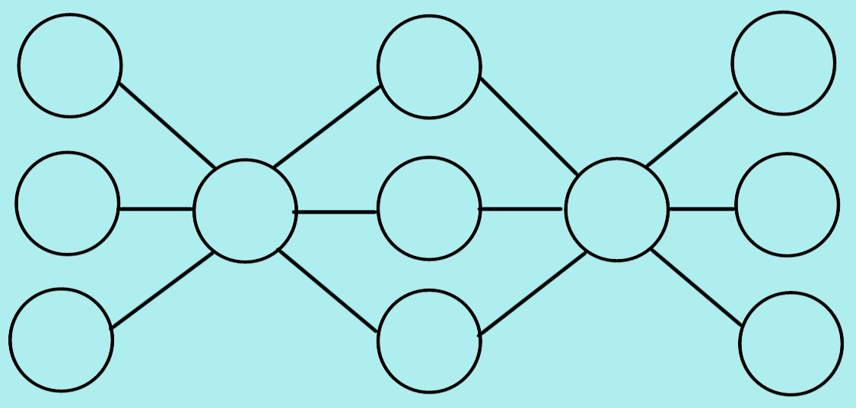

You may choose to write a paragraph comparing and contrasting the play and the original story. Or,
A story where someone makes a wish that causes horrible effects to happen is common. Often, the wisher is forced to use their remaining wishes to fix things.

Write your own short "disaster wish story" in your journal, using the cause
and effect structure. A multi-flow map will help:)

- Test on Monkey’s Paw

Wednesday: 9/11/13
Grammar: Verb tense agreement worksheet
Connect with Text: journal entry –Why do we love to be scared so much….
- Brainstorm a list of specific scary things you enjoy.
- Why do you think we like to be scared so much?
- Write a paragraph to explain how can being scared be a healthy or unhealthy thing?
Vocabulary words:
Acute, vexed, sagacity, refrained, wary, suavity, audacity, vehemently, gesticulations, derision

Smartboard “Which one doesn’t belong” group work

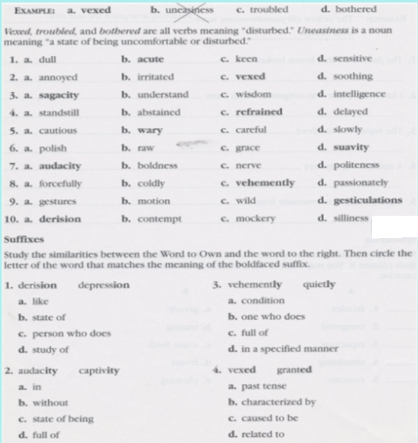

Activity 2
Use the "Words to Own" to fill in the blanks for the following sentences:

1. A wise general's________ was matched by his bold lieutenant's_______.
2. The children, whose hearing was________, ________ from speaking, and stayed quiet.
3. I feel either _______ or_______ when someone acts in a way that is scary.
4. The leader spoke_______ and with _______ when she yelled at the crew about their mistake.
5. The actor's_______ and dramatic _______ were considered before the audience clapped.

Thursday 9/12/13
1.) As always, before we read, we need to predict what the story may be about. Fill out the "My Story Impression" for "The Tell Tale Heart".

2.) Let's try a new prediction method! Look at the title, illustrations, and the opening quotation. These are text features.

Let's fill out a tree map with our predictions based on these text features.
Literary Elements
These are parts of a story that make the story complete.

Narrator: A person or character who is telling the story. We must trust this person to tell the story truthfully.

Listen to the narrator in this story and see if you trust him!

Other helpful elements you may know: exposition, conflict/complications(rising action), climax, resolution, character setting, mood, theme, tone, and point of view.
Let's Read!

-Pg. 202
-The Tell Tale Heart by Edgar Allen Poe
-As we read, fill out the literary elements on the back of the "Story Impression" worksheet.

